Hierarchical DNA Methylation model

Stan Model Fit Results

4/18/2020

Overview:

New results with informed priors: n_eff, Rhat summary

Distributions of model parameters

Example genes

Clustering, PCA

Distance-based analysis

Scores

Ratio of variances test

New Results with informed priors

Run took ~12 hours per job task, but tasks were not synchronized, took about 1 day total. Can probably speed up slightly but this will be good for more runs (testing other priors, etc)

Run parameters:

TCGA-informed priors:

mu ~ 0.3557*normal(-3.0675, 0.75214) + (1-0.3557)*normal(1.1290, 1.39197)

betaT ~ cauchy(-0.04051, 0.19330);

sigma_p ~ inv_gamma(6.3641, 1.6631);

sigma_pt ~ inv_gamma(3.2624, 1.5397);

sigma_t ~ inv_gamma(6.5392, 1.4894);

sigma_e ~ inv_gamma(1,1); //weakly informative inv-gamma for sigma_e

Chain parameters: chains=4, iter=2000, warmup=200, control = list(adapt_delta = 0.999)

Parameters stored: mu, betaT, sigmaP, sigmaPT, sigmaT, sigmaE, lp__ (log-posterior)

Stored values: mean, SEM, p50/median, n_eff, Rhat

Summary of n_eff for each parameter:

|  |  |  |  |  |
| --- | --- | --- | --- | --- |
| Parameter | Average n_eff | Min n_eff (site) | # n_eff <100 (%) | # n_eff <500 (%) |
| Mu | 3933.733 | 3.1052 (525490) | 104 (0.01%) | 988 (0.11%) |
| betaT | 3720.732 | 4.147812 (525490) | 29 (0.003%) | 437 (0.05%) |
| sigmaP | 1741.071706 | 2.834195 (525490) | 278 (0.03%) | 14649 (1.7%) |
| sigmaPT | 2690.40369 | 3.06373 (525490) | 165 (0.02%) | 2744 (0.3%) |
| sigmaT | 800.637077 | 7.041929 (570532) | 3009 (0.35%) | 280355 (32.4%) |
| sigmaE | 1274.916401 | 7.933103 (570532) | 881 (0.1%) | 77641 (9.0%) |
| Lp__ | 776.41309 | 13.95896 (854143) | 327 (0.04%) | 180096 (20.8%) |

And Rhat:

|  |  |  |  |  |
| --- | --- | --- | --- | --- |
| Parameter | Average Rhat | Max Rhat (site) | # Rhat>1.1 (%) | # Rhat>1.01 (%) |
| Mu | 1.000618 | 2.011041 (525490) | 32 (0.004%) | 824 (0.1%) |
| betaT | 1.000720 | 1.454651 (525490) | 4 (0.0005%) | 506 (0.6%) |
| sigmaP | 1.002598 | 2.443739 (525490) | 73 (0.008%) | 16032 (1.9%) |
| sigmaPT | 1.001278 | 2.229162 (827025) | 39 (0.005%) | 2286 (0.3%) |
| sigmaT | 1.007281 | 1.210336 (570532) | 66 (0.008%) | 197178 (22.8%) |
| sigmaE | 1.003707 | 1.285486 (287316) | 27 (0.003%) | 49971 (0.58%) |
| Lp__ | 1.007272 | 1.099968 (854143) | 0 (0%) | 186065 (21.5%) |

Problem sites:

525490, 570532, 827025, 287316

854143 only showed up for lp

Site 525490: Traceplots:



Posteriors:



Fit plot:



Low n_effs could have been prevented with warmup = 1000, but this sort of delayed warmup/poor mixing could just occur randomly… we can check directly after running a site that either n_eff is at some threshold or use another diagnostic measure to indicate we should run with a new random seed. If it persists after one re-run then drop site from analysis?

Site 570532:

Traceplots:



Posteriors:

  
Fit Plot:



The traceplots for this site make it seem like the posteriors are unstable in general, maybe depends on sigmaT + sigmaE inverse relationship? I think for this kind of site the results are unreliable because the chains aren’t mixing well, so the site should be thrown out of analysis

Site 827025:

Traceplots:



Posteriors:



Fitplot:



Similar to first site (525490), that sigmaP and sigmaPT hit a local minima then tradeoff and reach a more stable point, longer warmup would not have helped much (2000?)

Site 287316:

Traceplots:



Posteriors:



Fitplot:



This looks just generally unstable, especially for sigmaPT and sigmaP. Mu and betaT look ok?

Fit plot shows 2 patients with extraneously high values, can model handle these outliers?

Site 854143:

Traceplots:



Posteriors:



Fitplot:



This site showed up with low n_eff and high Rhat for lp__ variable (shown above)

Looks like some of the sigma’s are unstable too

Re-ran all 5 of these problem sites with a different stan seed, here are just a brief description

* 525490:
  + still see 1 chain with delayed mixing in sigmaP+PT, mixes in ~600 iter, one chain jumps out then back in for ~100 iter.
  + N_eff low/Rhat high in mu, betaT, sigmaP, sigmaPT
  + SigmaT+E have >900 n_eff, good Rhat<1.01
* 570532:
  + still see sigmaT, sigmaE unstable
  + N_eff low/Rhat high in sigmaT+sigmaE
  + Rest have 360-600 n_eff, Rhat ~1.01
* 827025:
  + still see 2 chains with delayed mixing in sigmaP+PT, mix in at ~600 and ~1200 iter
  + N_eff low/Rhat high in mu, betaT, sigmaP, sigmaPT
  + SigmaT+E have >900 n_eff, good Rhat<1.01
* 287316:
  + still see instability in sigmaP, sigmaPT, sigmaE
  + N_eff low/Rhat high in all sigmas
  + Mu+betaT have >5000 n_eff, good Rhat<<1.001
* 854143:
  + still see sigmas unstable
  + sigmaT + sigmaE have n_eff <200, lp__ n_eff<400
  + Rest are ok

So using a new seed only worked to fix the lp__ n_eff (from 13) on 854143

Other sites still run into same issues – delayed mixing or instability

Decide on how to deal with sites with bad fits:

* Need a consistent measure/cutoff
* Changing warmup interval (likely won’t fix problem)
* Re-running any fits? (might not even work if sites unstable)
* Throw out these sites from further analysis?
  + May be losing information for certain genes (small site #)
  + But still probably best for the analysis

Below are general results from the new full scale run with TCGA priors

Distribution of Parameters:

Showing distributions of median posterior values for each parameter

With prior overlays in red (coming soon)



Previous results with uniform priors:



Log-sigmas and log-sigma-ratios: 

Previous results with uniform priors:



Sigma vs Sigma plots (left: 2D histogram all data; right: contour plots using ~1:10 thinning):



Previous results with uniform priors:



Sigma Values as they vary by Gene Region:



Previous results with uniform priors:



Clustering, PCA:

**Clustering**:

*K-means clustering – kmeans(data.frame)*

Left is using 3 clusters, Right is using 4 clusters

*Fuzzy C-means clustering – cmeans(data.frame)*

Not very different from the K-means, but still considered a more reliable method

*GMM cluster?* – 2 slow haven’t gotten results

There may be more we can do with clustering if we can somehow consider all of the sites in a gene together (i.e. cluster based on where the entire group of sites in a gene are distributed?)

* Or just cluster based on the mean values for each gene
  + This will take time due to the time for indexing unless I can speed this up
  + Otherwise will need to use the cluster/parallel processing to process genes, mainly due to the indexing of sites in a gene, so we can lump gene-wise analyses together if this is the case
  + Hopefully can just speed up with regex
* Incorporate mu + betaT, which would provide information about the native methylation state and change in tumors

**PCA:**

The 3 PCA axes were determined to be the following linear combinations (% var explained):

PC1 = 0.380*sigmaP + 0.744*sigmaPT + 0.550*sigmaT (53.6%)

PC2 = 0.842*sigmaP – 0.031*sigmaPT – 0.539*sigmaT (26.3%)

PC3 = 0.384*sigmaP – 0.668*sigmaPT + 0.638*sigmaT (20.1%)

Below are plots of the projections of all sites onto each pair of the 3 components:

Previous data from uniform priors:





Clustering on PCA?

**tSNE**:

[insert tSNE, should be a 2D plot?]

Got tSNE to work in R? Not sure the 2D plot just looked like a big circle (need to re-plot)

The algorithm ran but took about an hour

Also testing a “Spectrum” algorithm – also very slow

Usually I’ve seen tSNE used to sort out RNA-seq data from multiple cell types, which works great if you build the tSNE score from a linear combination of the gene expression, etc

However, our data is 3 dimensions of log-sigma values (can add mu + betaT) across 850K sites, with one value for each site from the fit of all of the patients’ bulk tumor methylation data

So it’s not exactly the same data arrangement as multiple cells’ gene expression (which would be much higher dimensionality, and fewer samples)… still could work with sites as the samples and the 3 log-sigma values as features, it’s just not going to cluster as nicely as tSNE on different cell types

We are also not considering mu or betaT in these clustering analyses, though it could offer additional information? I.e. clustering methylated vs de-methylated regions, we could tie this back to recapitulate differential methylation analyses

* Compare sigmaPT (variance of tumor effect) to betaT (magnitude of tumor effect)
* Any effect of high or low mu (methylated/unmethylated state), also could consider those methylated/unmethylated in the tumor by looking at mu+betaT

Some Example Genes:

Here we will look at a few example genes, below is a list with a short description of each gene

GAPDH = important enzyme in glycolysis, therefore important to normal and cancer

(glycolysis maybe upregulated in some cancers)

APC = adenomatous polyposis coli, oncogene commonly involved in familiar colon cancer

TTN = titin, one of largest genes, only expressed in (cardiac) muscle, not in colon tissue

HLA-A = human leukocyte antigen A, Type 1 MHC immune presentation gene, maybe downregulated in cancer as a means of immune evasion

TP53 = p53, a major tumor suppressor, expect to be regulated in normal, dysregulated in cancer

Example gene plots (individual sites on sigmaP/PT/T plots) on the way

TODO:

* add plots for each gene on the PCA/tSNE axes
* table of cluster labels (as % of cluster 1, 2, 3 (4) in genes sites)
* add grand mean of gene to sigma x sigma plots, and add alpha to colored points?
* Anything involving mu/betaT?

CpG-Distance-Based Analysis

Based on the analysis in Darryl’s paper “Epigenetic Conservation Is a Beacon of Function:An Analysis Using Methcon5 Software for Studying Gene Methylation” by Hvitfeldt et al 2020.

One of the analyses in the paper looks at the average conservation (here the conservation score is based on average pairwise distance) in relation to the distance of the CpG site from the 5’-most CpG site in the gene

Below is the figure from Darryl’s paper:

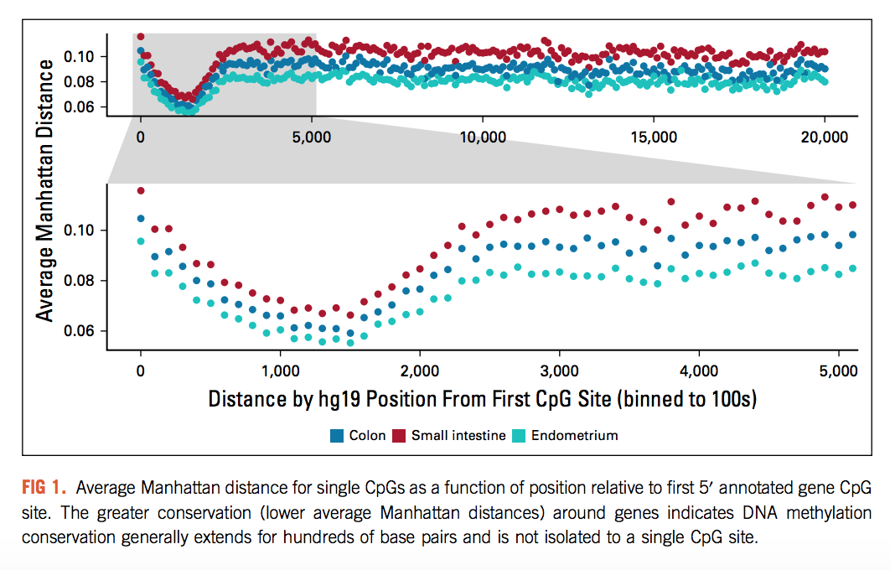

Want to see if our data can replicate this phenomenon

This is my first-pass attempt (old results):



Obstacles run into:

1. The CpG site annotation of the EPIC array indicates the CpG site base position on its chromosome, and also tells if it is on the F or R strand… but this does not exactly specify which direction is 5’ for the gene
   1. Could maybe work around this by looking at the smallest value for the F strands?
   2. This still doesn’t say which way the F strand is facing
   3. Might need to bring in external gene annotation data, something that can define the base range and direction of each gene
   4. Currently just using the lowest CpG site position value as leftmost…. Definitely wrong

Therefore, I still need to complete the analysis here correctly, but it is a good analysis to work on. Recapitulating what Darryl’s paper found would be good, because they found an interesting phenomenon of conservation being very high with a small range of distance near the start of the gene.

Brainstorming more analyses:

General ideas include showing that our results can replicate some common findings of methylation conservation that have been studied before, just a few basic analyses to show our model is valid

Can compare to pairwise-distance type conservation analyses

* + Darryl’s paper shows conservation and gene expression are correlated
  + They also do a nice CpG-distance analysis, and use a bootstrapping method for scoring?
  + Along with some gene ontology